**7 Reasons Why Hospitality Companies Should Use a BPO**

The importance of first-rate customer service and efficient operations cannot be overstated in the fiercely contested and customer-focused hospitality sector. This is the context in which Business Process Outsourcing (BPO) emerges as a significant factor. BPO involves delegating specific tasks or processes, such as reservation services and reception services, to external quality customer service, a strategy that comes with numerous benefits.

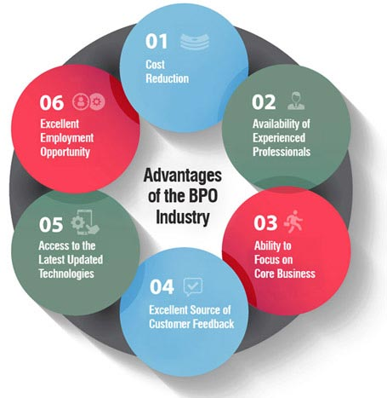

[Source](https://cdn.flatworldsolutions.com/images/articles/bpo-industry-advantages-benefits.jpg)

For entities in the travel and hospitality industry, the use of BPO can be a transformative decision. The following are seven compelling reasons to consider this approach.

## **Cost Savings**

In the world of travel and hospitality companies, one of the most impactful ways to hospitality industry reduce costs is by leveraging the power of Business Process Outsourcing (BPO). There is a significant potential for cost reduction when BPO is properly integrated, particularly because third-party service providers already possess the required infrastructure and proficiency.

When a company outsource call centers using third-party provider, it removes the necessity for said company to make substantial investments in these areas, hence the overall operational costs can be significantly curtailed. This situation is even more applicable when considering that these third-party service providers are often equipped to handle specialized tasks, such as booking and reservation duties, that are vital in the hospitality sector. Having a ready-made solution to tackle these duties not only enhances efficiency but also leads to substantial savings.

These service providers often operate as travel agency call centers, which provide essential communication channels between businesses and customers. Outsourcing these call centers to BPO providers ensures seamless operations and improves customer service due to their expertise and dedicated focus on these tasks.

The savings realized from this outsourcing can then be redirected to bolstering core operations that define the company's unique offering. Furthermore, these savings can be channeled into developing innovative services or scaling up the business, thereby increasing competitiveness in the market.

## **Access to Expertise**

Business Process Outsourcing (BPO) companies are known for their ability to deliver an extensive range of specialized services. These services encompass areas such as customer service, data management, accounting, and IT support. They are also notably proficient in delivering essential services like multilingual call center services that cater to a diverse global audience.

The advantage for hospitality businesses in this context is clear. When these businesses choose to outsource, they get to access an entire team of seasoned professionals who are specialized in various areas that might not be readily available within their in-house teams. Outsourced teams often excel in handling customer service duties, which is a critical aspect of the hospitality industry. They have the training, experience, and tools to manage customer relations effectively, resulting in greater customer satisfaction.

The expertise of these outsourced teams is not confined to traditional areas but also extends to up-to-date services like multilingual call center services. Such services are invaluable in the current globalized world where hospitality businesses often serve foreign guests who speak different languages. With multilingual call centers, businesses can ensure that they offer convenient communication channels to all guests, regardless of their language preference. This enhances customer experience and builds a positive brand image across diverse demographics.

Additionally, outsourcing to BPO companies allows hospitality businesses to use the latest technology and systems in these call centers. These advanced systems ensure that all processes, from customer service to data management, are carried out efficiently and securely. This level of efficiency contributes to high-quality service delivery, an aspect that is paramount in the hospitality industry.

In this light, outsourcing to BPO companies can significantly enhance the competitiveness of a hospitality business. With access to a diverse range of specialized services and a team of experts, these businesses can ensure high-quality service delivery, thus creating an edge in the fiercely competitive hospitality industry. The advantage extends to improved customer relations and satisfaction, particularly with the incorporation of multilingual call center services, thereby fostering an inclusive and positive experience for all guests.

## **Scalability**

One of the remarkable benefits that Business Process Outsourcing (BPO) offers to companies is the ability to effortlessly scale operations, either upwards or downwards, in response to varying demand levels. In many industries, but particularly so in the hospitality industry, the demand for services is not a constant; it can oscillate wildly, often aligning with seasons or influenced by other external factors such as market trends, socio-political circumstances, or global events.

The hospitality industry is marked by its cyclic nature, with peaks and troughs in demand that coincide with holiday seasons, special events, or even changes in weather patterns. These fluctuations require a high degree of adaptability in order to adequately meet demand at peak times and to reduce unnecessary expenses during slower periods. Traditional business models may struggle with this volatility, often leading to inefficiencies, but this is where BPO can offer a significant advantage.

With a BPO provider as a strategic partner, a hospitality business can tap into an immense reservoir of flexibility. These providers have the capability to rapidly expand operations during peak periods, ensuring that the business can meet increased customer demand without compromising service quality or efficiency. At the same time, during periods of reduced demand, these operations can be scaled down to reflect the lower activity levels, allowing the business to minimize operational costs.

This ability to quickly adapt to changing demand is a crucial factor in maintaining a continuous and efficient service, which is a cornerstone of success in the hospitality industry. BPO providers can implement these changes swiftly, in line with business needs. They achieve this through a combination of robust staffing models, technological solutions, and operational strategies, which allow them to handle fluctuations in demand seamlessly.

## **Focus on Core Business**

Companies can devote more time and resources to their primary business activities by outsourcing non-core processes, like improving guest services, developing new strategies, or investing in marketing efforts. This can lead to improved performance and profitability in the long run.

## **24/7 Customer Support**

In the hospitality industry, customer service is a critical factor. Outsourcing to a BPO can provide around-the-clock customer support, ensuring that guests' queries and concerns are promptly addressed no matter the time zone. This can significantly enhance customer satisfaction and brand reputation.

## **Risk Mitigation**

BPO can also help hospitality companies manage risks. Providers have robust systems and procedures in place to handle various situations, including data breaches, customer complaints, or other operational issues. They also ensure regulatory compliance, which can be a complex and time-consuming task for companies to handle internally.

## **Innovation and Technology Access**

BPO companies are known for leveraging the latest technologies to enhance their service delivery. By outsourcing, hospitality businesses can benefit from these innovations without having to invest in acquiring and maintaining such technologies themselves. This includes advanced AI and machine learning tools, which can provide valuable insights and automate routine tasks.

To sum it up, leveraging BPO can provide numerous advantages for hospitality companies, from cost savings and scalability to access to expertise and advanced technologies. By strategically outsourcing certain processes, these businesses can enhance their service delivery, focus more on their core operations, and ultimately provide an exceptional guest experience.